Genetic Algorithms
Section #8
Constraint Satisfaction Problem (CSP)
Graph Coloring Problem (GCP)
In the mathematical branch of graph theory, a graph is a structured collection of objects that represents the relationships between pairs of these objects. The objects appear as vertices (or nodes) in the graph, while the relation between a pair of objects is represented using an edge. A common way of illustrating a graph is by drawing the vertices as circles and the edges as connecting lines, as depicted in the following diagram of the Petersen graph, named after the Danish mathematician Julius Petersen:

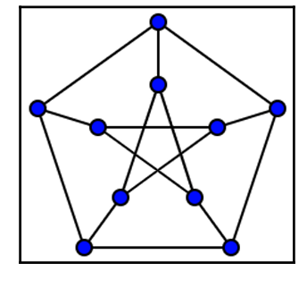
Graphs are remarkably useful objects as they can represent and help us research an overwhelming variety of real-life structures, patterns, and relationships, such as social networks, power grid layouts, website structures, linguistic compositions, computer networks, atomic structures, migration patterns, and more.
The graph coloring task is used to assign a color for every node in the graph in such a way that no pair of connected (adjacent) nodes will share the same color. This is also known as the proper coloring of the graph.

The following diagram shows the same Petersen graph, but this time colored properly:
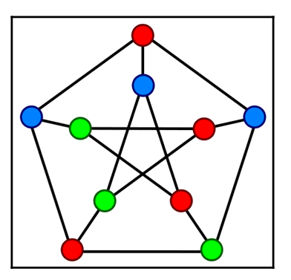
The color assignment is often accompanied by an optimization requirement – use the minimum possible number of colors. For example, the Peterson graph can be properly colored using three colors, as demonstrated in the preceding diagram. But it would be impossible to properly color it using only two colors. In graph theory terms, this means that the chromatic number of this graph is three.
Solution representation:-
Expanding on the commonly used binary list (or array) representation, we can employ a list of integers, where each integer represents a unique color, while each element of the list matches one of the graph's nodes.
For example, since the Petersen graph has 10 nodes, we can assign each node an index between 0 and 9. Then, we can represent the node coloring for that graph using a list of 10 elements.
For example, let's have a look at what we have in this particular representation:
(0, 2, 1, 3, 1, 2, 0, 3, 3, 0)
Let's talk about what we have here in detail: Four colors are used, represented by the integers 0, 1, 2, 3.
- The first, seventh, and tenth nodes of the graph are colored with the first color (0).
- The third and fifth nodes are colored with the second color (1).
- The second and sixth nodes are colored with the third color (2).
- The fourth, eighth, and ninth nodes are colored with the fourth color (3).
To evaluate the solution, we need to iterate over each pair of adjacent nodes and check if they share the same color. If they do, this is a coloring violation, and we seek to minimize the number of violations to zero to achieve the proper coloring of the graph.

Using hard and soft constraints for the graph coloring problem:-
When solving the nurse scheduling problem earlier in this chapter, we noted the difference between hard constraints – those we have to adhere to for the solution to be considered valid – and soft constraints – those we strive to minimize to get the best solution. In the graph coloring problem, the color assignment requirement – where no two adjacent nodes can have the same color – is a hard constraint. We have to minimize the number of violations of this constraint to zero to achieve a valid solution.

Minimizing the number of colors used, however, can be introduced as a soft constraint. We would like to minimize this number, but not at the expense of violating the hard constraint.

However, you may recall that we also seek to minimize the number of colors that are used. If we happen to already know this number, we can just use as many integer values as the known number of colors. But what if we don't? One way to go about this is to start with an estimate (or just a guess) for the number of colors used. If we find a proper solution using this number, we can reduce the number and try again. If no solution was found, we can increase the number and try again until we have the smallest number we could find a solution with. However, we may be able to get to this number faster by using soft and hard constraints, as described in the next subsection.
Implementation:-
Cell 1: Imports
import random
import networkx as nx
import matplotlib.pyplot as plt

Cell 2: Define Graph
G = nx.Graph()

edges = [
(0,1),(0,2),(1,2),(1,3),
(2,3),(3,4),(4,5),(5,0)
]

G.add_edges_from(edges)

NUM_NODES = G.number_of_nodes()
NUM_COLORS = 3

Cell 3: Create Individual (Genotype)
def create_individual():
return [random.randint(0, NUM_COLORS-1) for _ in range(NUM_NODES)]

Cell 4: Fitness Function
def fitness(individual):
conflicts = 0

for u, v in G.edges():
if individual[u] == individual[v]:
conflicts += 1

return -conflicts # maximize

Cell 5: Selection
def select(pop):
return max(random.sample(pop, 3), key=fitness)

Cell 6: Crossover
def crossover(p1, p2):
point = random.randint(1, NUM_NODES-1)
return p1[:point] + p2[point:]

Cell 7: Mutation
def mutate(ind):
if random.random() < 0.3:
i = random.randint(0, NUM_NODES-1)
ind[i] = random.randint(0, NUM_COLORS-1)
return ind

Cell 8: GA Loop
def run_ga():
pop = [create_individual() for _ in range(20)]
history = []

for gen in range(50):
new_pop = []

for _ in range(len(pop)):
p1 = select(pop)
p2 = select(pop)

child = crossover(p1, p2)
child = mutate(child)

new_pop.append(child)

pop = new_pop

best = max(pop, key=fitness)
best_fit = fitness(best)
history.append(best_fit)

print(f"Gen {gen}, Conflicts = {-best_fit}")

return best, history

Cell 9: Run GA
best_solution, history = run_ga()
print("\nBest Coloring:", best_solution)

Cell 10: Visualize Graph Coloring
def visualize_graph(solution):
color_map = solution
pos = nx.spring_layout(G)

nx.draw(G, pos,
node_color=color_map,
with_labels=True,
cmap=plt.cm.Set3,
node_size=800)

plt.title("Graph Coloring Result")
plt.show()

visualize_graph(best_solution)

